[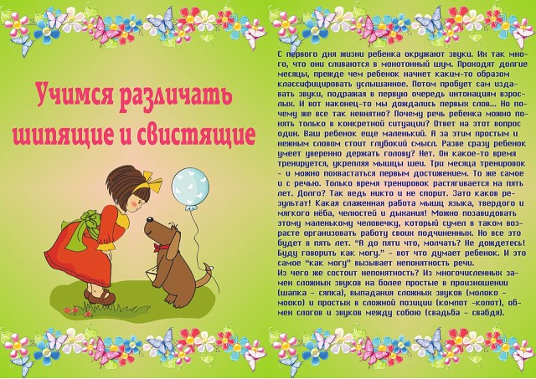](http://ok.ru/dk?cmd=PopLayerPhoto&st.layer.cmd=PopLayerPhotoOuter&st.layer.type=GROUP&st.layer.revNav=off&st.layer.limitedUi=false&st.layer.sphotoIds=815972798981;815972798725;815972798469;815972798213;815972797957;815972797701;815972797445;815972797189;815972796933;815972796677&st.layer.showNav=on&st.layer.photoAlbumId=53823353978885&st.layer.epm=off&st.layer.photoId=815972798981&st.layer.opl=off&st.layer.navStartPhotoId=815972798981&st.layer.sbd=off&st.cmd=altGroupForum&st.groupId=47337259335685&st._aid=GroupTopicLayer_openPhotoLayer)

[](http://ok.ru/dk?cmd=PopLayerPhoto&st.layer.cmd=PopLayerPhotoOuter&st.layer.type=GROUP&st.layer.revNav=off&st.layer.limitedUi=false&st.layer.sphotoIds=815972798981;815972798725;815972798469;815972798213;815972797957;815972797701;815972797445;815972797189;815972796933;815972796677&st.layer.showNav=on&st.layer.photoAlbumId=53823353978885&st.layer.epm=off&st.layer.photoId=815972798725&st.layer.opl=off&st.layer.navStartPhotoId=815972798725&st.layer.sbd=off&st.cmd=altGroupForum&st.groupId=47337259335685&st._aid=GroupTopicLayer_openPhotoLayer)

[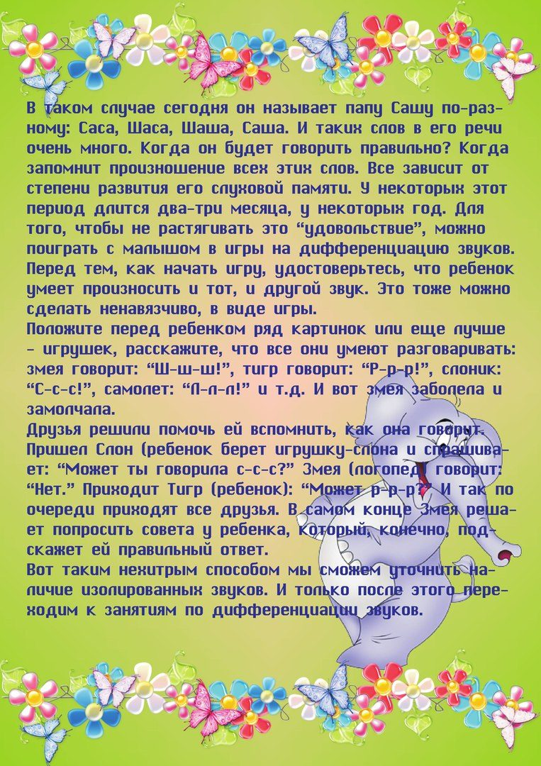](http://ok.ru/dk?cmd=PopLayerPhoto&st.layer.cmd=PopLayerPhotoOuter&st.layer.type=GROUP&st.layer.revNav=off&st.layer.limitedUi=false&st.layer.sphotoIds=815972798981;815972798725;815972798469;815972798213;815972797957;815972797701;815972797445;815972797189;815972796933;815972796677&st.layer.showNav=on&st.layer.photoAlbumId=53823353978885&st.layer.epm=off&st.layer.photoId=815972798469&st.layer.opl=off&st.layer.navStartPhotoId=815972798469&st.layer.sbd=off&st.cmd=altGroupForum&st.groupId=47337259335685&st._aid=GroupTopicLayer_openPhotoLayer)

[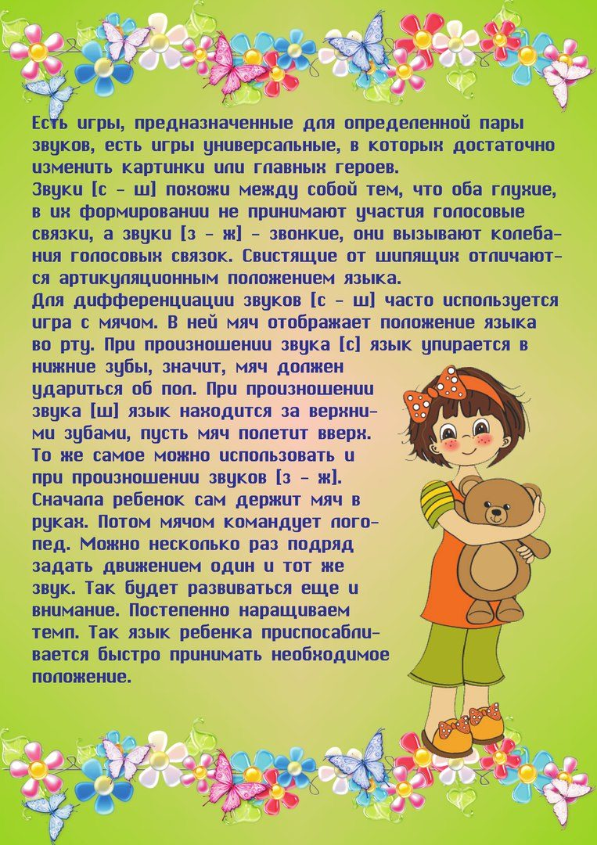](http://ok.ru/dk?cmd=PopLayerPhoto&st.layer.cmd=PopLayerPhotoOuter&st.layer.type=GROUP&st.layer.revNav=off&st.layer.limitedUi=false&st.layer.sphotoIds=815972798981;815972798725;815972798469;815972798213;815972797957;815972797701;815972797445;815972797189;815972796933;815972796677&st.layer.showNav=on&st.layer.photoAlbumId=53823353978885&st.layer.epm=off&st.layer.photoId=815972798213&st.layer.opl=off&st.layer.navStartPhotoId=815972798213&st.layer.sbd=off&st.cmd=altGroupForum&st.groupId=47337259335685&st._aid=GroupTopicLayer_openPhotoLayer)

[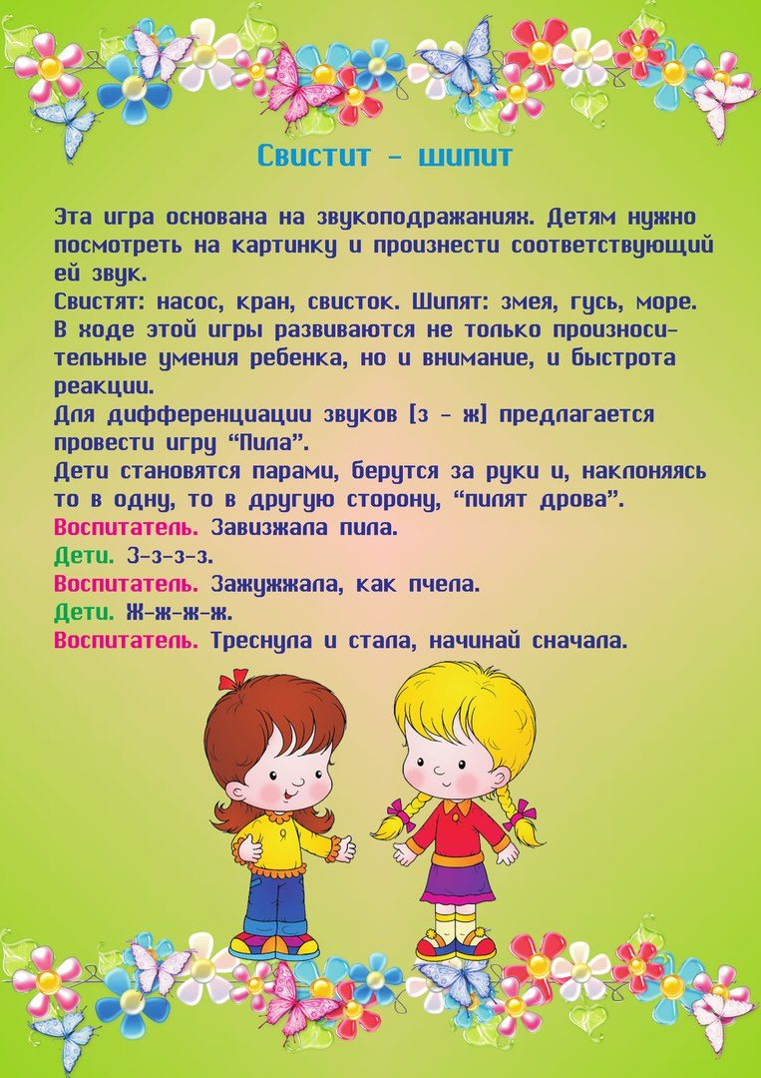](http://ok.ru/dk?cmd=PopLayerPhoto&st.layer.cmd=PopLayerPhotoOuter&st.layer.type=GROUP&st.layer.revNav=off&st.layer.limitedUi=false&st.layer.sphotoIds=815972798981;815972798725;815972798469;815972798213;815972797957;815972797701;815972797445;815972797189;815972796933;815972796677&st.layer.showNav=on&st.layer.photoAlbumId=53823353978885&st.layer.epm=off&st.layer.photoId=815972797957&st.layer.opl=off&st.layer.navStartPhotoId=815972797957&st.layer.sbd=off&st.cmd=altGroupForum&st.groupId=47337259335685&st._aid=GroupTopicLayer_openPhotoLayer)

[](http://ok.ru/dk?cmd=PopLayerPhoto&st.layer.cmd=PopLayerPhotoOuter&st.layer.type=GROUP&st.layer.revNav=off&st.layer.limitedUi=false&st.layer.sphotoIds=815972798981;815972798725;815972798469;815972798213;815972797957;815972797701;815972797445;815972797189;815972796933;815972796677&st.layer.showNav=on&st.layer.photoAlbumId=53823353978885&st.layer.epm=off&st.layer.photoId=815972797701&st.layer.opl=off&st.layer.navStartPhotoId=815972797701&st.layer.sbd=off&st.cmd=altGroupForum&st.groupId=47337259335685&st._aid=GroupTopicLayer_openPhotoLayer)

[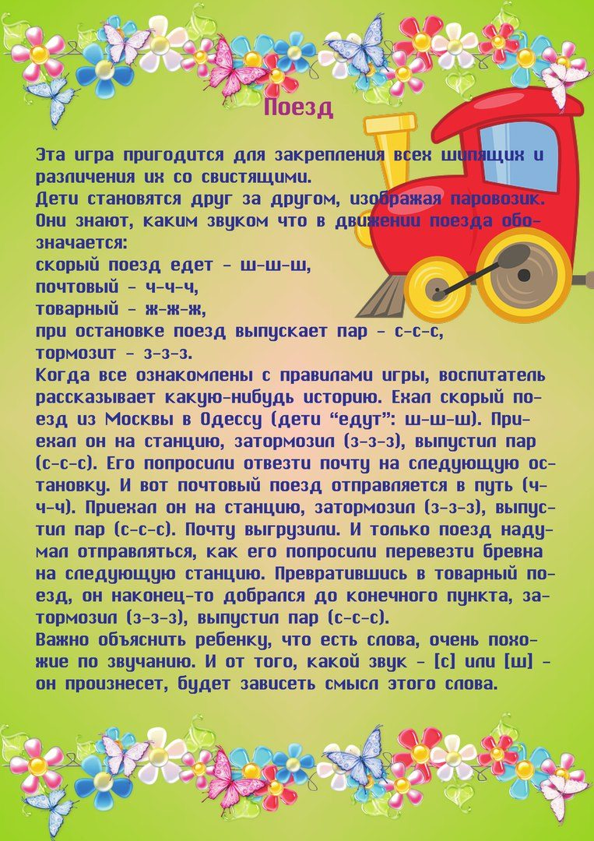](http://ok.ru/dk?cmd=PopLayerPhoto&st.layer.cmd=PopLayerPhotoOuter&st.layer.type=GROUP&st.layer.revNav=off&st.layer.limitedUi=false&st.layer.sphotoIds=815972798981;815972798725;815972798469;815972798213;815972797957;815972797701;815972797445;815972797189;815972796933;815972796677&st.layer.showNav=on&st.layer.photoAlbumId=53823353978885&st.layer.epm=off&st.layer.photoId=815972797445&st.layer.opl=off&st.layer.navStartPhotoId=815972797445&st.layer.sbd=off&st.cmd=altGroupForum&st.groupId=47337259335685&st._aid=GroupTopicLayer_openPhotoLayer)

[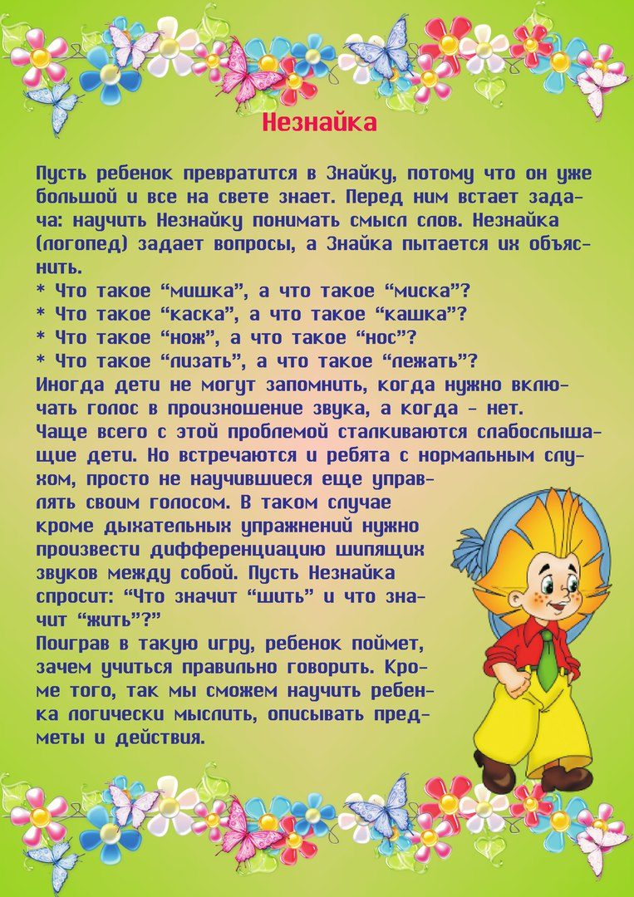](http://ok.ru/dk?cmd=PopLayerPhoto&st.layer.cmd=PopLayerPhotoOuter&st.layer.type=GROUP&st.layer.revNav=off&st.layer.limitedUi=false&st.layer.sphotoIds=815972798981;815972798725;815972798469;815972798213;815972797957;815972797701;815972797445;815972797189;815972796933;815972796677&st.layer.showNav=on&st.layer.photoAlbumId=53823353978885&st.layer.epm=off&st.layer.photoId=815972797189&st.layer.opl=off&st.layer.navStartPhotoId=815972797189&st.layer.sbd=off&st.cmd=altGroupForum&st.groupId=47337259335685&st._aid=GroupTopicLayer_openPhotoLayer)

[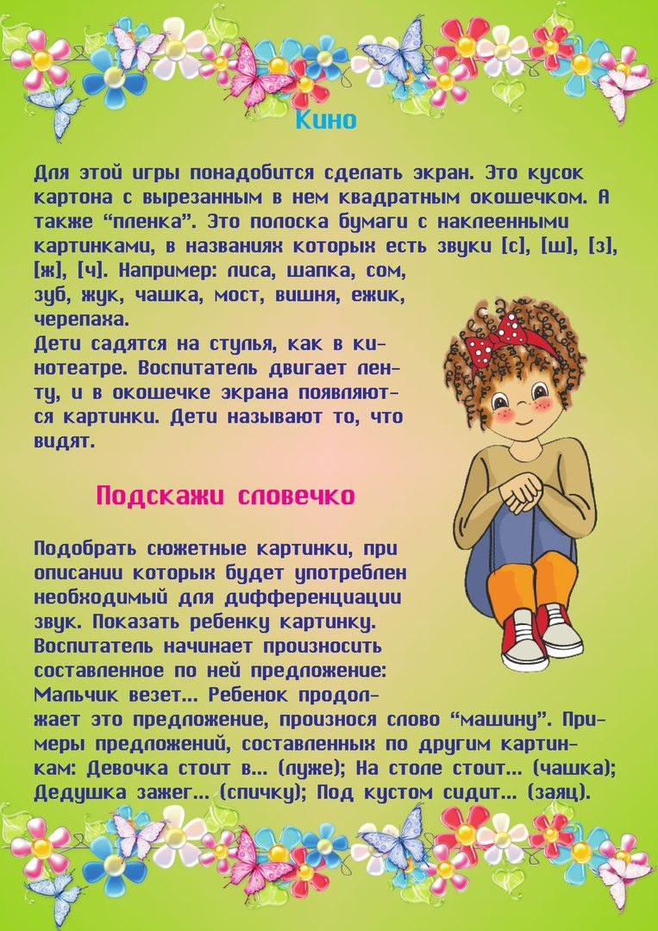](http://ok.ru/dk?cmd=PopLayerPhoto&st.layer.cmd=PopLayerPhotoOuter&st.layer.type=GROUP&st.layer.revNav=off&st.layer.limitedUi=false&st.layer.sphotoIds=815972798981;815972798725;815972798469;815972798213;815972797957;815972797701;815972797445;815972797189;815972796933;815972796677&st.layer.showNav=on&st.layer.photoAlbumId=53823353978885&st.layer.epm=off&st.layer.photoId=815972796933&st.layer.opl=off&st.layer.navStartPhotoId=815972796933&st.layer.sbd=off&st.cmd=altGroupForum&st.groupId=47337259335685&st._aid=GroupTopicLayer_openPhotoLayer)

[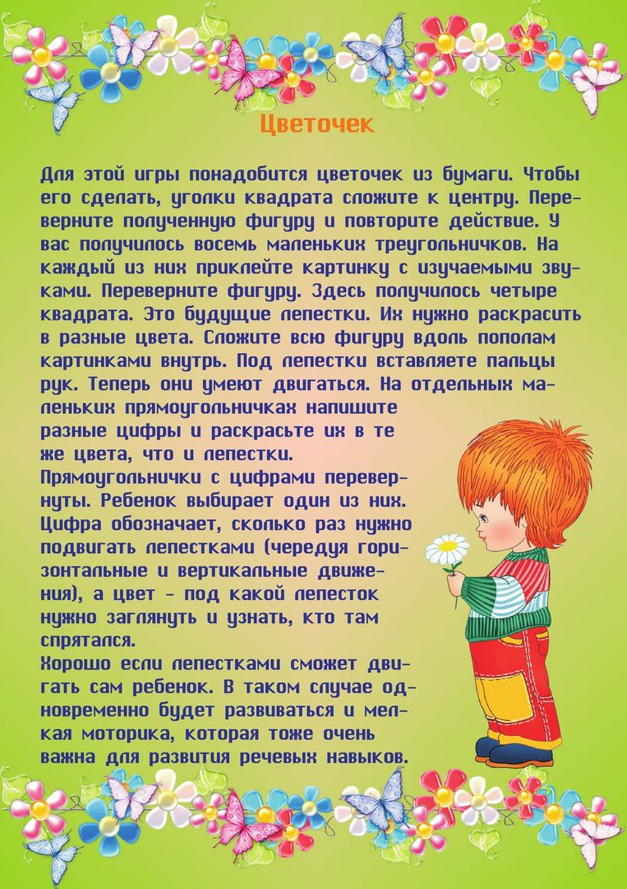](http://ok.ru/dk?cmd=PopLayerPhoto&st.layer.cmd=PopLayerPhotoOuter&st.layer.type=GROUP&st.layer.revNav=off&st.layer.limitedUi=false&st.layer.sphotoIds=815972798981;815972798725;815972798469;815972798213;815972797957;815972797701;815972797445;815972797189;815972796933;815972796677&st.layer.showNav=on&st.layer.photoAlbumId=53823353978885&st.layer.epm=off&st.layer.photoId=815972796677&st.layer.opl=off&st.layer.navStartPhotoId=815972796677&st.layer.sbd=off&st.cmd=altGroupForum&st.groupId=47337259335685&st._aid=GroupTopicLayer_openPhotoLayer)